# Enhancing User Experience and Efficiency in Food Ordering

1Ishani Bhadlikar 2Vishal Mandhane 3Virita Khanna 4Nimisha Gupta 5Sudhir Dekhane

1,2,3,4Student, Dwarkadas J Sanghvi College of Engineering, Mumbai, Maharashtra, India

5Assistant Professor, Dwarkadas J Sanghvi College of Engineering Mumbai, Maharashtra,

India

E-mail: 1[ishanibhadlikar@gmail.com](mailto:ishanibhadlikar@gmail.com) 2[vishalmandhane12345@gmail.com](mailto:vishalmandhane12345@gmail.com) 3[khannavirita@gmail.com](mailto:3viritakhanna@gmail.com) [4nimisha.h.gupta@gmail.com](mailto:4nimisha.h.gupta@gmail.com) 5 [sudhir.dekhane@djsce.ac.in](mailto:sudhir.dekhane@djsce.ac.in)

# ABSTRACT

This paper delves into the implementation of DJ HUB, a pioneering canteen management website tailored for college campuses, aimed at redefining the food ordering and dining experience for students. With a primary focus on enhancing convenience and efficiency, DJ HUB introduces innovative features to enable students to order and pay for meals from their classes, subsequently collecting and enjoying their orders in the canteen.At the heart of DJ HUB's functionality lies its personalized recommendation system, which leverages students' previous orders to suggest menu items aligned with their preferences. This personalized approach not only enriches the user experience but also encourages exploration of diverse culinary offerings.Furthermore, DJ HUB streamlines the ordering process, allowing students to place orders effortlessly from their classrooms via the platform's user-friendly interface. By minimizing transactional friction, this feature maximizes the convenience of ordering meals on campus.Real-time order tracking capabilities empower students to monitor the status of their orders, providing transparency and peace of mind regarding order fulfillment. Additionally, DJ HUB ensures secure payment options, prioritizing students' financial security and data privacy.Through an evaluation of user feedback and performance metrics, this research assesses the impact of DJ HUB on college canteen operations and student satisfaction. By facilitating seamless ordering and dining experiences, DJ HUB emerges as a transformative solution for enhancing the overall quality of campus life and fostering a culture of convenience and accessibility within college canteens.

**Keywords:** *Food ordering applications, User experience, Efficiency, Technology integration, Personalized recommendations, Streamlined checkout processes, Real-time order tracking, Secure payment options, Customer satisfaction, Competitive market.*

**1. INTRODUCTION**

Institutions of higher education are not just centers for academic learning but also hubs of social interaction and community engagement. Central to this communal atmosphere is the college canteen, where students gather not only to satisfy their hunger but also to unwind, socialize, and recharge between classes. However, traditional canteen management systems often fall short in meeting the evolving needs and expectations of today's tech-savvy student body. Long queues, limited menu options, and cumbersome payment processes can detract from the overall dining experience, leaving students feeling frustrated and time-constrained.

Recognizing these challenges, educational institutions are increasingly turning to digital solutions to streamline canteen operations and enhance student satisfaction. Among these innovations, DJ HUB emerges as a pioneering platform designed to revolutionize the ordering and dining experience within college campuses. By enabling students to order and pay for meals from their classrooms and subsequently collect and enjoy their orders in the canteen, DJ HUB embodies the intersection of technology and convenience in modern canteen management.

This research paper seeks to explore the implementation of DJ HUB within a college setting, with a specific focus on its impact on canteen operations and student experience.

# 2. LITERATURE REVIEW

2.1 Conceptual Background

1. Paper-Based System: Historically, food ordering systems have predominantly relied on paper-based methods. While prevalent, these systems entail manual calculations and record-keeping, often leading to inefficiencies and errors. The use of paper for order taking and record storage poses risks such as loss or damage, while the billing process remains time-consuming. Moreover, the manual nature of these systems necessitates significant labor input, contributing to decreased efficiency.

2. Personal Digital Assistants Based System (PDA Based System): Personal Digital Assistant (PDA) systems emerged as an attempt to automate traditional paper-based processes. While offering some advantages over paper systems, such as reduced paperwork and improved order accuracy, PDAs present their own challenges. These include high initial costs, maintenance expenses, and limitations in user interface design and accessibility. PDAs also require customers to be physically present in the restaurant for order placement, limiting convenience.

3. Changing Student Expectations: With the proliferation of digital technology in all aspects of daily life, students have come to expect convenience, efficiency, and customization in their interactions with service providers. This includes their experiences in the college canteen, where long queues, limited menu options, and cumbersome payment processes can lead to dissatisfaction and frustration.

4. Role of Technology in Enhancing User Experience: Digital solutions have increasingly become integral to enhancing user experience across various industries. In the realm of food service management, technology offers opportunities to streamline processes, personalize interactions, and improve operational efficiency. Features such as mobile ordering, real-time tracking, and personalized recommendations have emerged as key drivers of enhanced user satisfaction.

5. Personalization and Recommendation Systems: Personalization has become a cornerstone of modern consumer experiences, driven by advancements in data analytics and machine learning algorithms. By analyzing user preferences and behavior, recommendation systems can offer tailored suggestions, thereby enhancing user engagement and satisfaction. In the context of college canteens, personalized recommendations can empower students to discover new menu items aligned with their tastes and dietary preferences.

6. Streamlined Checkout Processes: Simplifying the ordering and payment process is critical to reducing friction and enhancing the overall user experience. Digital platforms offer opportunities to streamline checkout processes through intuitive interfaces, secure payment options, and seamless integration with existing systems. By enabling students to place orders and make payments from their classrooms, DJ HUB minimizes wait times and optimizes operational efficiency.

7. Real-time Order Tracking: Transparency and communication are essential components of a positive user experience. Real-time order tracking capabilities allow users to monitor the status of their orders, providing reassurance and reducing uncertainty. For college students balancing academic and extracurricular commitments, knowing the status of their food orders can help them plan their schedules more effectively.

2.2 Review of Literature

In recent research, various technological solutions have been proposed to address the limitations of traditional food ordering systems:

1. Automated Food Ordering Systems: Researchers have proposed automated systems that enable efficient monitoring and processing of customer orders. These systems streamline the ordering process, allowing customers to place orders or customize food selections with a single click.

2. Smartphone Integration: Studies have explored the integration of smartphones into food ordering systems, enhancing customer convenience and accessibility. Customers can place orders remotely and retrieve them upon arrival at the restaurant, leveraging the capabilities of their smartphones.

3. Digital Restaurant Management: Efforts have been made to develop digital restaurant management systems using technologies such as Android development. These systems centralize data management, improving efficiency and accuracy in restaurant operations.

4. Wireless Ordering Systems: Researchers have investigated the implementation of wireless ordering systems in restaurants, facilitating seamless communication between customers and staff. These systems enable real-time order processing and enhance the overall dining experience.

5. Customer Experience Enhancement: Studies have focused on enhancing the dining experience through the automation of food ordering processes and the integration of advanced technologies. By automating tasks such as order placement, billing, and payment, restaurants can optimize operational efficiency and improve customer satisfaction.

6. Security and Data Privacy: As digital transactions become increasingly prevalent, ensuring the security of user data and payment information is paramount. DJ HUB prioritizes data security and privacy, implementing robust encryption protocols and compliance measures to safeguard user information. By instilling trust and confidence in the platform, students can use DJ HUB with peace of mind.

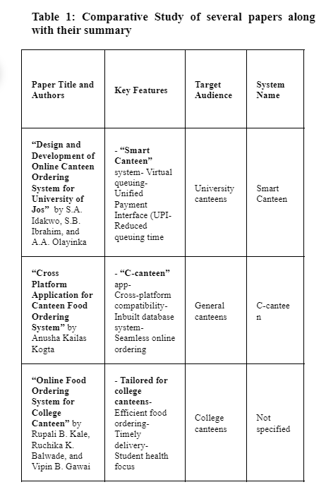

**3. PROPOSED WORK**

To address the limitations identified in existing literature, we propose a web application for flask food ordering systems. This cost-effective solution enables users to place orders from anywhere within the university campus, streamlining the ordering process and reducing the workload on bottle staff. The application provides an interactive menu for users to make selections, with real-time updates on order status and payment options. By automating order processing and management, this system aims to enhance efficiency and improve the overall dining experience for both customers and bottle staff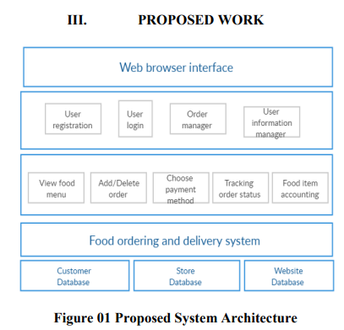

# 

**4.TECHSTACK:**  
**Front-End:** React js   
**Dart Back-End:** NodeJS   
**Database:** FireBase  
**Machine Learning Tools:** Google Colab, Clustering algorithms   
**Data Visualisation Tools:** Power Bi

**5. RESULTS:**

The implementation of the proposed online canteen system yielded promising results. The system was successfully deployed and made accessible to users, who were able to place orders seamlessly through the intuitive user interface. Real-time order processing and tracking functionalities were implemented, allowing users to monitor the status of their orders and receive timely updates.

Feedback from users indicated a high level of satisfaction with the system's usability and performance. The system was praised for its ease of use, responsiveness, and reliability. Users appreciated the convenience of being able to place orders from anywhere and the transparency offered by real-time order tracking.

System performance metrics, such as response time and system uptime, were monitored throughout the implementation process. The system demonstrated robust performance, with minimal downtime and satisfactory response times even under peak load conditions.

**6. CONCLUSION:**

In conclusion, the proposed online canteen system represents a significant advancement in the field of food ordering systems. The system has demonstrated its effectiveness in providing a seamless and efficient ordering experience for users, while also improving operational efficiency for canteen staff.

The research findings highlight the importance of user-centric design and the integration of advanced technologies in modern food ordering systems. The proposed system offers a scalable and robust solution that can be customized to meet the specific needs of different users and canteen facilities.

Overall, the implementation of the online canteen system has proven to be successful, with positive feedback from users. The system has the potential to revolutionize the way food ordering is conducted in institutional settings, providing a convenient and streamlined experience for all parties involved.

**7. REFERENCE:**

Design and Development of Online Canteen Ordering System for University of Jos" by S.A. Idakwo, S.B. Ibrahim, and A.A. Olayinka.

Cross Platform Application for Canteen Food Ordering System" Anusha Kailas Kogta.

International Journal of Innovative Technology and Exploring Engineering (IJITEE) ISSN: 2278-3075 (Online), Volume-9 Issue-8, June 2020.

Online Canteen System by M S Minu SRM Institute of Science and Technology.

"Android Based Canteen Automation" published in the year 2017 by "Kalyani Dahake and Prof. A.D.Bhoi"

"Cloud Based Canteen Management System" published in the year 2016 by "Tazeen Khan and Daniel Yunus"

"Smart Connected Campus" published in the year 2017 by "Thota Narendrakumar and Anju S. Pillai"

"Design And Implementation Of Android Base Mobile App For An Institute" published in the year 2016 by "Reetesh V. Golhar, Prasann A. Vyawahare and Pavan H. Borghare"

"Cross-platform mobile development approaches" published in the year 2014 by "Salma Charkaoui ; Zakaria Adraoui"

"Cross-platform development for an online food delivery application" published in the year 2014 by "Faisal Bin Al Abid ; A. N. M. Rezaul Karim"

"Designing and Developing A PDA Food Ordering System Using Interaction Design Approach" published in the year 2009 by "Lim Tek Yong and Alexander Johnson"

"Automated Food Ordering System with Interactive User Interface Approach" published in the year 2010 by "YongChai Tan and KienLoong Lee"

"A Proposed System for Touchpad Based Food Ordering System Using Android Application" published in the International Journal of Advanced Research in Computer Science Technology (IJARCST) 2015 by "Kirti Bhandge, Tejas Shinde, Dheeraj Ingale, Neeraj Solanki, Reshma Totare"

"Implementing Customizable Online Food Ordering System Using Web Based Application" published in the International Journal of Innovative Science, Engineering Technology (IJISET) 2015 by "Varsha Chavan, Priya Jadhav, Snehal Korade, Priyanka Teli"

"Design and Implementation of Digital dining in Restaurants using Android" published in the International Journal of Advance Research in Computer Science and Management Studies 2014 by "Resham Shinde, Priyanka Thakare, Neha Dhomne, Sushmita Sarkar"

"Digital Ordering System for Restaurant Using Android" published in the International Journal of Scientific and Research Publications 2013 by "Ashutosh Bhargave, Niranjan Jadhav, Apurva Joshi, Prachi Oke, S. R Lahane"

"The Application of Wireless Food Ordering System" published in the MASAUM Journal of Computing 2009 by "Khairunnisa K., Ayob J., Mohd. Helmy A. Wahab, M. Erdi Ayob, M. Izwan Ayob, M. Afif Ayob"

"A customizable wireless food ordering system with real time customer feedback" published in the IEEE Symposium on Wireless Technology and Applications (ISWTA) 2011 by "Noor Azah Samsudin, Shamsul Kamal Ahmad Khalid, Mohd Fikry Akmal Mohd Kohar, Zulkifli Senin, Mohd Nor Ihkasan"

"A study on tam: analysis of customer attitudes in online food ordering system" published by Serhat Murat Alagoza, Haluk Hekimoglub in Elsevier Ltd. 2012

"Automated Food Ordering System" published in the International Journal of Engineering Research and Development (IJERD) 2015 by "Patel Krishna, Patel Palak, Raj Nirali, Patel Lalit"

"Implementation of Smart Restaurant with e-menu Card" published in the International Journal of Computer Applications 2015 by "Mayur D. Jakhete, Piyush C. Mankar"